**DAILY ONLINE ACTIVITIES SUMMARY**

|  |  |  |  |  |  |  |  |
| --- | --- | --- | --- | --- | --- | --- | --- |
| **Date:** | **22-06-2020** | | | | **Name:** | **B.A.SOHANKUMAR** | |
| **Sem & Sec** | **4TH SEM A** | | | | **USN:** | **4AL18CS013** | |
| **Online Test Summary** | | | | | | | |
| **Subject** | | **----** | | | | | |
| **Max. Marks** | | **----** | | **Score** | | **----** | |
| **Certification Course Summary** | | | | | | | |
| **Course** | **CLOUD COMPUTING WITH AWS** | | | | | | |
| **Certificate Provider** | | | **GLA** | **Duration** | | | **12 HOURS** |
| **Coding Challenges** | | | | | | | |
| **Problem Statement: Write a java program for modular exponentiation.** | | | | | | | |
| **Status: EXECUTED** | | | | | | | |
| **Uploaded the report in Github** | | | | **YES** | | | |
| **If yes Repository name** | | | | **LOCKDOWN CODING** | | | |
| **Uploaded the report in slack** | | | | **YES** | | | |

**CERTIFICATION COURSE DETAILS:**

Course: CLOUD COMPUTING WITH AWS

Completed modules today are Module 7 - Auto Scaling,Module 8 - Amazon Machine Image or AM,IModule 9 - AWS Command Line Interface,Module 10 - Forms of Storage on Cloud,Module 11 - Block Storage - EBS,Module 12 - Elastic File System,Module 13 - Object Storage - Simple Storage Service.

 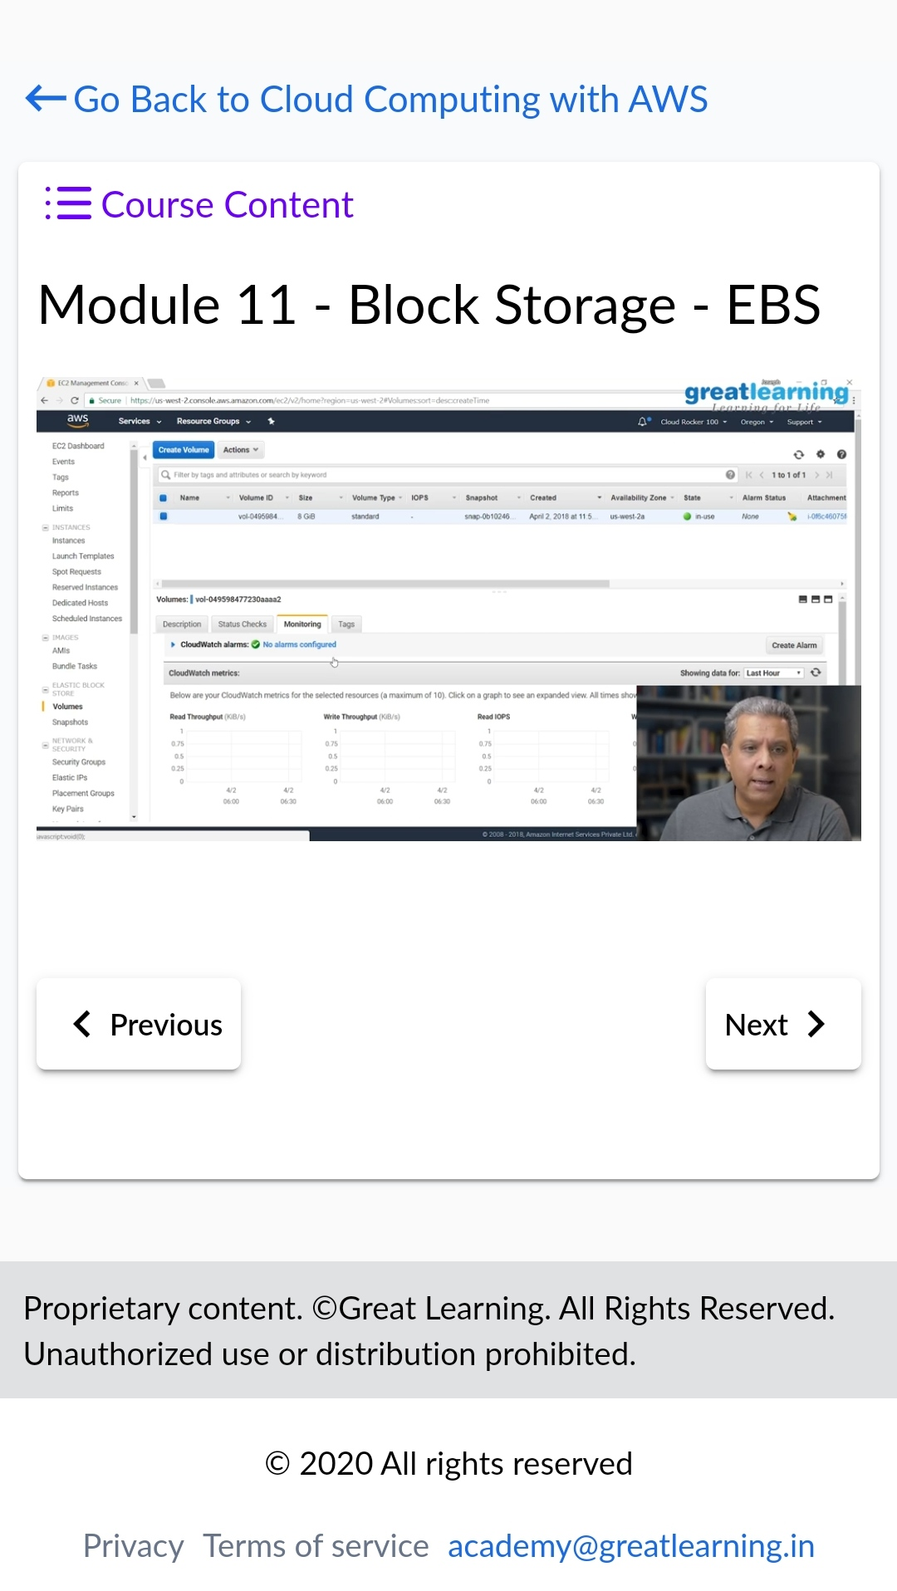

**CODING CHALLENGES DETAILS::**

1.Write a Java Program for Modular Exponentiation .Given three numbers x, y and p, compute (xy) % p.

Input: x = 2, y = 3, p = 5

Output: 3

Explanation: 2^3 % 5 = 8 % 5 = 3.

Input: x = 2, y = 5, p = 13

Output: 6

Explanation: 2^5 % 13 = 32 % 13 = 6.

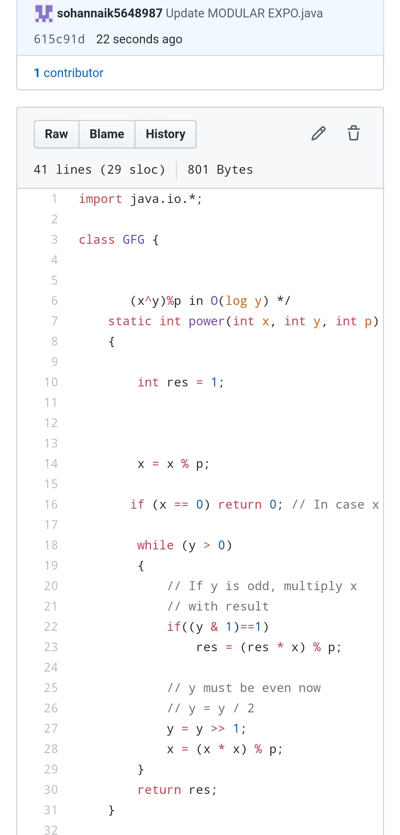

REPOSITORY LINK:https://github.com/sohannaik5648987/JAVA-CODING